Organization: The Hook
You can always start writing and do the hook later.
YOU COULD START WITH…
- A Short Sentence (5 or less words)
Her hair shone gold.

- An Interesting Question or Riddle
Who has big eyes, big teeth, and is dressed in Grandma’s clothes? Yes, that’s right; it’s the Big Bad Wolf!

- A Bold Statement/Challenge
Grimm’s fairy tales are superior to all others.

- An Announcement/ Capture Emotion
Readers might be surprised to learn that a little girl couldn’t recognize her own grandmother.

- Lots of fabulous Adjectives
Tall, dark, and with an air of confidence, the woodsman entered the house.

- A Single word
Fear. This emotion was coursing through Red’s veins, pumping from her heart into every limb as she saw the wolf’s sharp teeth.

- An Interesting Fact
Wolves are some of the most misunderstood and misrepresented predators of all time.

- Exploding your own moment (or imagining a moment in time)
My eyes, peeled open like ripe bananas, searched for Grandma’s porch-light, my beacon in the dark. Breathing in short, wispy clouds, I felt my fingers going numb. I had stayed too long in the woods, and now as night descended, I knew I was truly lost.

- A (famous) Quotation
“Grandma, what big eyes you have.”

- Stating a Belief
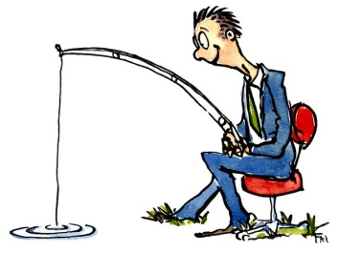
Fairy tales are more than just stories. Each has a moral or lesson to be learned.

